***Cloning***

Open source on git hub:

<https://github.com/dkhamsing/open-source-ios-apps>

<https://github.com/austinzheng/swift-2048>

git clone <https://github.com/austinzheng/swift-2048.git> //clone repository

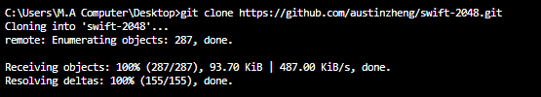

Its folder is created with files in desktop (cloned) shown below.

